HackerRank - Grading Students
Code:
#include <stdio.h>
int main() {
int n;
scanf("%d", &n);
int grades[n];
for (int i = 0; i < n; i++) {
scanf("%d", &grades[i]);
}
for (int i = 0; i < n; i++) {
if (grades[i] >= 38) {
int remainder = grades[i] % 5;
if (remainder >= 3) {
grades[i] = grades[i] + (5 - remainder);
}
}
}
for (int i = 0; i < n; i++) {
printf("%d\n", grades[i]);
}
return 0;
}

Screenshot:

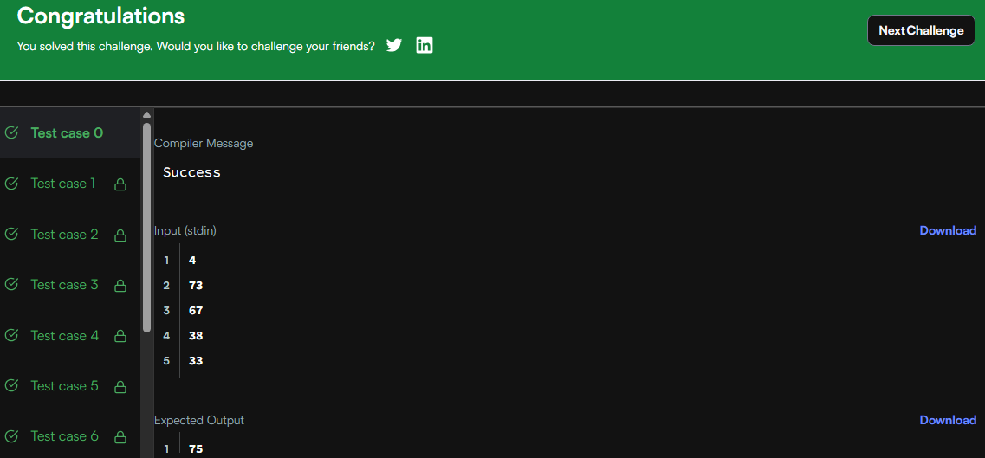

Link:
https://www.hackerrank.com/challenges/grading/problem

